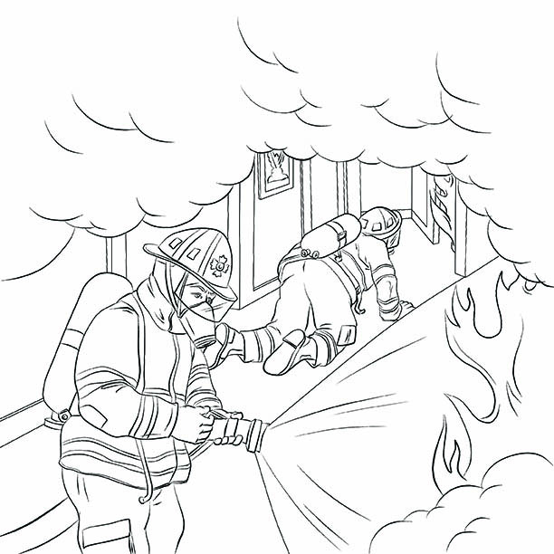

Uncle Rocky crawls past Big Joe.
Uncle Rocky, Fireman Book #1 Fire!
By James Burd Brewster
All “Glad To Do It!” books are available at Amazon.com.
Readers can download extra coloring pages or contact Mr. Brewster at www.GladToDoIt.net

