Monday April 20th - Coping with Covid - Morning
Laugh it off: Ben asked, 'Grandpa, may I play my harmonica in the house?' 'Yes,” Grandpa said. “I love music. In fact, when Grandma and I were young, music saved my life.' 'What happened?' Grandpa began, “During the Johnstown flood, the dam broke, the water hit our house, and knocked it off the foundation. Grandma got on the dining room table and floated out safely.' 'How about you, Grandpa?' asked Ben. 'Me? I accompanied her on the piano!'
God’s Comfort: Prov 21:1-3 1 Do not be envious of evil men, Nor desire to be with them; 2 For their heart devises violence, And their lips talk of troublemaking. 3 Through wisdom a house is built, And by understanding it is established; Psalm 121:1-8 I will lift up my eyes to the hills—From whence comes my help? 2 My help comes from the Lord, Who made heaven and earth. 3 He will not allow your foot to be moved; He who keeps you will not slumber. 4 Behold, He who keeps Israel Shall neither slumber nor sleep. 5 The Lord is your keeper; . . . 7 The Lord shall preserve you from all evil; He shall preserve your soul. 8 The Lord shall preserve your going out and your coming in From this time forth, and even forevermore.
Pray daily - God is easy to talk to: Lord, grant me tenacious courage as I go through this day. When I am tempted to give up, help me to keep going. Grant me a cheerful spirit when things don't go my way. And give me courage to do whatever needs to be done. In Jesus' name, Amen. —Dr. Ray Pritchard
National Day Today (April 20): Boston Marathon, Chinese Language Day, Lima Bean Respect Day, Look a Like Day, Cheddar Fries Day, Pineapple Upside-Down Cake Day, Patriot's Day,
Coloring Page: Free coloring pages and book download - Uncle Rocky Fireman – Fire! at www.Gladtodoit.net. Need a pastor? Jim Brewster at Gladtodoit@gmail.com or 202-557-8097.
Monday April 20th - Coping with Covid - Noon
Laugh it off: Q:Why can't you play cards on a pirate ship? A: The captain keeps standing on the deck. - - Q: How do you make a tall pirate short? A: You take all his money. - - Q: What does the ocean say when it sees the shore? A: Nothing, it just waves. - - Q: What happened to the man with two wooden legs when his trousers caught fire? A: He was burnt to the ground.
God’s Comfort: Acts 2:41-47 41 Then those who gladly received his word were baptized; and that day about three thousand souls were added to them. 42 And they continued steadfastly in the apostles’ doctrine and fellowship, in the breaking of bread, and in prayers. 43 Then fear came upon every soul, and many wonders and signs were done through the apostles. 44 Now all who believed were together, and had all things in common, 45 and sold their possessions and goods, and divided them among all, as anyone had need. 46 So continuing daily with one accord in the temple, and breaking bread from house to house, they ate their food with gladness and simplicity of heart, 47 praising God and having favor with all the people. And the Lord added to the church daily those who were being saved.
Historical Perspective (April 20): 1841 - Edgar Allen Poe's "The Murders in the Rue Morgue," published in Graham's Magazine. 1850 - Daniel Chester French born - Sculptor, (Minute Man statue, Abraham Lincoln in Lincoln Memorial). 1889 - Adolf Hitler born. 1902 - Marie and Pierre Curie isolated radioactive element radium. 1912 - Fenway Park Boston opened. 1937 - George Takei born- Actor (Mr. Sulu on Star Trek) 1955 - Bo Diddley plays the Apollo Theater. 1959 - Dolly Parton's "Puppy Love," released. 1999 - Jane Seymour gets star on Hollywood Walk of Fame.
Writing for Fun: ABC Poem – Make a list of things you like
Sample: Things I Like  Being Creative  Making things  Cooking Cake  Driving with my Wife  Floating Island’s Dessert  My Grandkids  I Hear The Owl Call My Name (Book)  Organizing Projects  Sailing  Lake Champlain  My Parents  Chocolate Chip Ice Cream  Bach’s Cello Prelude (Suite 1 G Maj) | Your: Things I Like
Free coloring pages and book download - Uncle Rocky Fireman – Fire! at www.Gladtodoit.net. Need a pastor? Jim Brewster at Gladtodoit@gmail.com or 202-557-8097..
Monday April 20th - Coping with Covid - Supper
Laugh it off: Crime Does Not Pay: In Nashville, a burglar fell asleep on the sofa of the home he was robbing, only to be awakened by police. - - In Thibodaux, Louisiana, a robber with a thick Cajun accent couldn't get restaurant patrons to understand his demand for money. Frustrated, he pulled his gun, but it wouldn't fire. He grabbed the cash register and ran...but only got three feet and fell. The register was plugged into the wall. Unplugging it, he tried again, but a diner knocked him down and called the police. - - In Rhode Island, police were sure they had the suspect in a string of coin-machine thefts when the suspect paid his $400 bail in quarters.
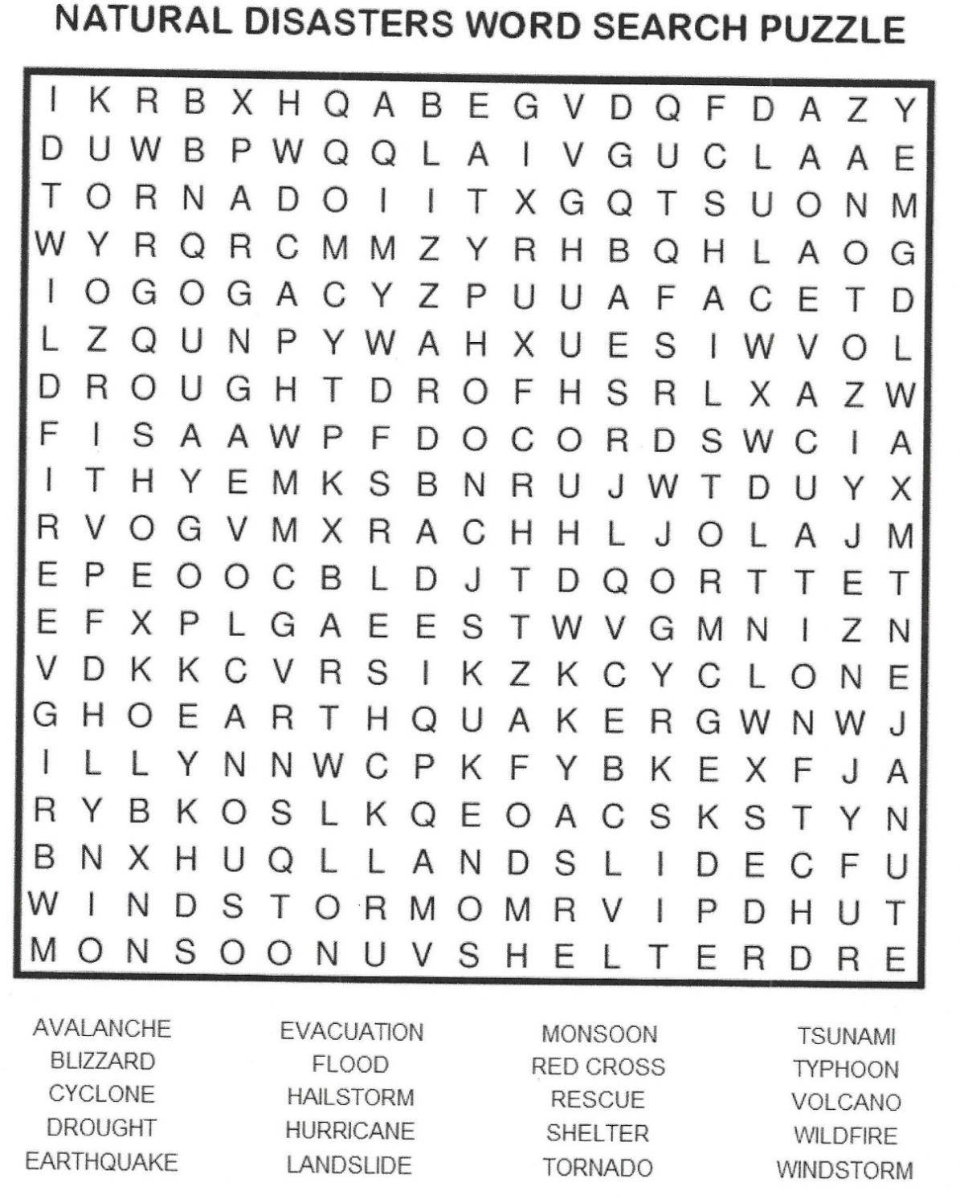
God’s Comfort: Matthew 6:31-34 31 “Therefore do not worry, saying, ‘What shall we eat?’ or ‘What shall we drink?’ or ‘What shall we wear?’ 32 For after all these things the Gentiles seek. For your heavenly Father knows that you need all these things. 33 But seek first the kingdom of God and His righteousness, and all these things shall be added to you. 34 Therefore do not worry about tomorrow, for tomorrow will worry about its own things. Sufficient for the day is its own trouble.
Quotes/Other Wisdom: “All I was trying to do was get home from work.” – Rosa Parks
I consider myself the luckiest man on the face of the earth. And I might have been given a bad break, but I’ve got an awful lot to live for. – Lou Gehrig – Farewell Speech
Games: Natural Disasters Word Search
Free coloring pages and book download - Uncle Rocky Fireman – Fire! at www.Gladtodoit.net. Need a pastor? Jim Brewster at Gladtodoit@gmail.com or 202-557-8097.

